7.5: a) In the absence of air resistance, Eq. (7.5) is applicable. With 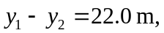 solving for 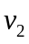 gives
b) The result of part (a), and any application of Eq. (7.5), depends only on the magnitude of the velocities, not the directions, so the speed is again 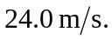 c) The ball thrown upward would be in the air for a longer time and would be slowed more by air resistance.

